Chaplaincy Bulletin – Issue 3
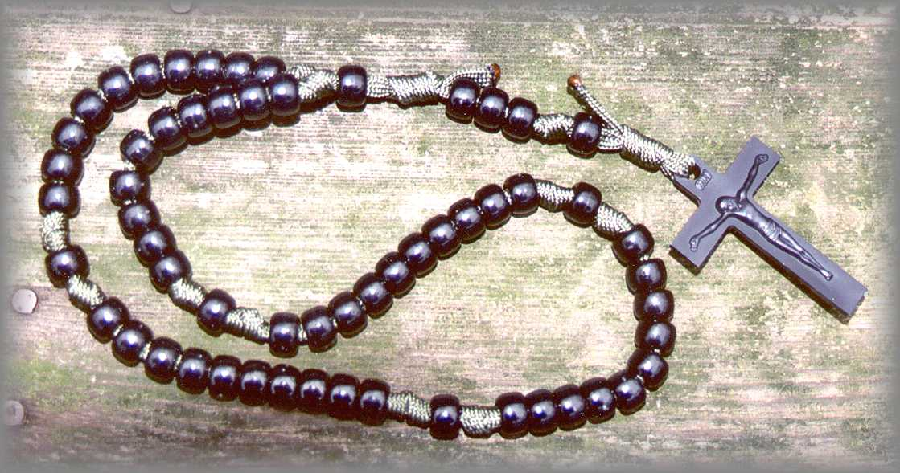

- Rosary Club – Rosary club has begun and is held every break time for ten minutes in the chapel for the month of May. All are welcome. There are a lot of misguided preconceptions regarding Catholics and the rosary and so Rosary Club allows students to ask questions as well as pray. Rosaries are provided and a step by step explanation is given every time.
- Friday Morning Mass – As always, Mass will be celebrated at 8am in our chapel every Friday morning. 7NW will be helping to prepare the Mass for Friday 15th May . 7JA will be next.
- Lightfever –The next Lightfever is Friday 22nd May All staff and students are welcome. 12.30 – 1.15pm
- Assemblies – Until half term, assemblies will be led by Leaders of Learning. We will be ensuring that there is a clear focus to assemblies and that they are of a spiritual nature and reflect the ethos of the college. As always, Cleo is on hand in order to help with ideas and resources.
- Chaplaincy Team – The chaplaincy team will be recruiting some new members as year 13 leave. Any ideas of responsible year 12’s who might be interested, please let Cleo know.
- Break time Mass group – The chaplaincy team are available in the chapel every Friday break time to stamp the reward cards that they created for Mass goers. They also hand out sweets to those who have attended and chat informally and answer any questions.
- Chaplaincy Board – The board will change after Half Term.
- VIDES – VIDES has been going well so far and students seem to be enjoying it. We are starting off small and hoping to gradually increase numbers. VIDES is a Salesian based youth group for students in year 7 & 8. It is held on a Friday after school and led by the chaplaincy team. Please give me names of any students that you feel will benefit from a regular youth group and I will invite them.
- Vocations week – Next week is vocations week in St. Michael’s college. There will be a selection of priests, nuns and male and female religious orders coming in to college and talking to students about their own vocation. One order in particular, is a closed order which means they never leave the convent and have no interaction with the outside world. This is an amazing opportunity for students and staff to ask questions and find out more, as well as thinking about their own calling and the path that they are on in life.

Music Assemblies
Last week I got the opportunity to be a part of the music assemblies in the college. I have been a part of the band since year 7, playing saxophone, and so in the assembly it was great to not only be a part of the band again, but to also stand up and tell others how being a part of a team has taught me so much. As a band member we learn qualities such as teamwork, trust, courage, how to listen to each other, humility and confidence. The band is like a human body. All different parts working together as one. Now that I am in the sixth form, I use my gifts and talents to give back to music by helping pupils starting out on their musical journey and mentor the junior band. - Luke – Yr. 12 student

V.I.D.E.S
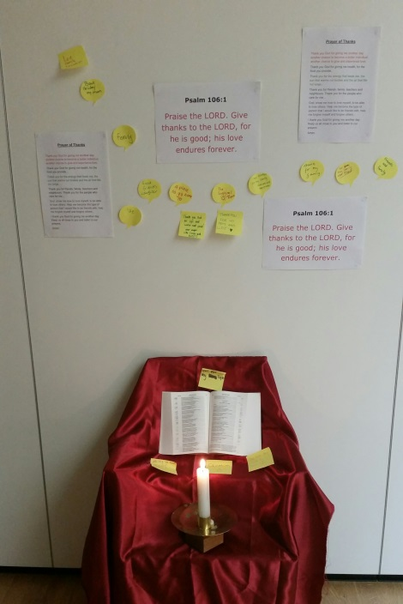
This was my first experience of VIDES ad I really enjoyed it. We played a game where we had a sticker on our back and we had to try to guess who we were and then the next week we played a few games that got us laughing and talking to each other. The 6th form and year 10 helpers joined in and they are really nice.
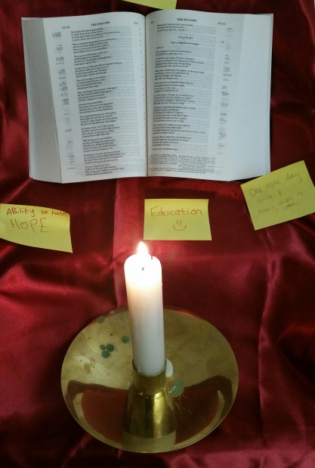
We also had really nice prayer times where we thought about what we are thankful for. Last week we had a word scramble race to find out what V.I.D.E.S stands for. It was really hard but our team won.
I am looking forward to the next session. – Katie - Year 7 Student

W

- Volunteer Movement
- International
- Development
- Education
- Salesian

