Chaplaincy Bulletin – Issue 2

- Rosary Club – Traditionally in the Catholic Church, in the months of May and October we pray the rosary. We started Rosary Club in October and there were a few students and staff that came regularly. Please publicise this in your classes and feel free to come along yourself. Every break time for 10mins in the chapel.
- Friday Morning Mass – As always, Mass will be celebrated at 8am in our chapel every Friday morning. 7HO will be helping to prepare the Mass for Friday 24TH April . 7NW on 8th May.
- Lightfever – Once a month we hold a special prayer time in the chapel. Students and staff are invited to come and pray and light a candle in front of “The Blessed Sacrament” (Jesus). The next Lightfever is 24th April All staff and students are welcome. 12.30 – 1.15pm
- Assemblies – The next lot of assemblies will be led by S.E.N.D and the Student Leadership Team. They have produced a leaflet which will be widely available. Following this will be Literacy week led by the English Dept in celebration of Shakespeare’s birthday. And then Celebrating Music.
- Chaplaincy Team meeting – The chaplaincy team meet every Monday after school. They are made up of students from Year 13, 10, 9, 8 &7. The team will lead Rosary club and VIDES as well as helping with Friday Mass.
- Break time Mass group – The chaplaincy team are available in the chapel every Friday break time to stamp the reward cards that they created for Mass goers. They also hand out sweets to those who have attended and chat informally and answer any questions.
- Chaplaincy Board – The board has changed to a message of Hope and New Life.
- VIDES – VIDES is a Salesian based youth group for students in year 7 & 8. It is held on a Friday after school and led by the chaplaincy team. Please give me names of any students that you feel will benefit from a regular youth group and I will invite them.

Easter Service
What I liked most about the Easter Service was the song that they sang at the end. It was fun and I liked the instruments and they sang very well. I also liked seeing other students on the video talking about what suffering was. – Yr 7 student
The response from the Easter service was really positive. Students and staff enjoyed being involved either in reading or music. Comments from staff and students were that it was something different and reflective.

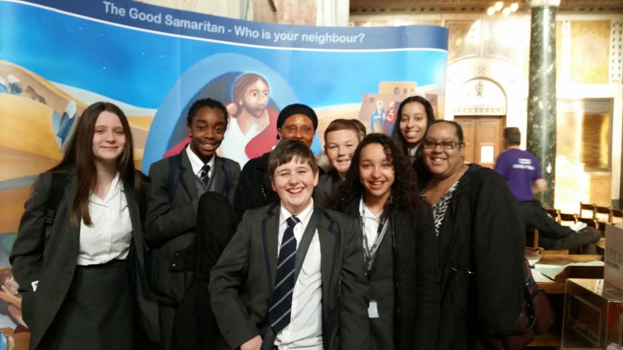
The Good Samaritan Mass
On Wed 18th March, Cleo and Ms Arobaga took us to Westminster Cathedral for the Good Samaritan Mass. This was really good fun. I was surprised at how big and beautiful the cathedral was and there were loads of children from other schools.
The best part was watching the priest sign the Mass and the songs as we sang them. I was even tempted to join in and see if I could copy him. I enjoyed singing the songs and chatting to people from other years. – Yr 8 Student

Science and Engineering week Assemblies
For Science and Engineering week Ms O’Leary led the assemblies which were really good fun. She talked about how Science is everywhere and used a lot, even when we don’t realise it and also did some really cool experiments like shaking up two bottles of coke and testing theories for how to not make it fizz over so much. We ended the assembly with a prayer that thanked God for scientists and for all our gifts and talents. - Yr. 7 Student

